# Day Use Form

Please list all students who will be participating. For students requiring rentals fill in the following:

* shoe size
* ski size (see chart)
* pole size (see chart)

The list should be sent to the club two days prior to the visit. Email to: [northbaynordic@gmail.com](mailto:northbaynordic@gmail.com).

A copy will be kept at the club of the students and their sizes so the equipment can be ready upon each arrival.

For consecutive visits email a list of who is or is not coming so the equipment can be put out accordingly.

If no equipment rental is required please check off the column next to the student’s name. We require a record of all students for billing purposes.

# Clubhouse Guidelines

* back packs are to be kept downstairs
* ensure students place winter boots out of the walkways
* returned skis are to be placed with tips up
* returned boots are to be placed on the boot rack
* all equipment must be returned to the clubhouse before departure
* students are encouraged to bring water bottles
* teachers should ensure all trash and litter is picked up and put in the appropriate containers
* lost and found is located in the basement
* please collect the equipment information cards for each student (an envelope will be provided for each school)

# Scheduling

C:\Documents and Settings\Julie Risling\Local Settings\Temporary Internet Files\Content.IE5\E3ZEDV6N\MC900156753[1].WMFIt is important to let us know when your school would like to use the trails to make sure we have enough rentals and personnel on hand. Available dates are posted on the website ([www.northbaynordic.ca](http://www.northbaynordic.ca)) on the events calendar. To reserve a date, email the school liaison.

If your event is cancelled, please contact the club at 705- 495-0332 and notify the school liaison.

We will let you know if the trails are closed due to poor trail conditions.

# School Group Rates

A school can obtain a “school membership” from the North Bay Nordic Ski Club for an annual fee of $100 (tax included). This allows all students from your school to use our trails on school days as part of a school outing. This eliminates the need to pay trail fees. The membership money should be collected by the supervising teacher and paid to the Snack Bar staff on the first visit.

Receipts will be available at the club upon your next visit.

# Equipment Rental

We have an adequate amount of equipment for rent for skiers of all sizes. Skate skis are not included in the rentals. A list of the rental inventory can be found on the website under rates and hours and then under equipment rentals.

For school membership groups, a complete set of equipment (skis, poles and boots) is available at a cost of $6 (tax included) per student. The rental fees for each student should be collected by the supervising teacher and paid to the Snack Bar staff at each visit to the club.**Sizing Guide**

|  |  |  |
| --- | --- | --- |
| Height | Pole Size | Ski Size |
| 4’ | 95 cm | 140 |
| 4’1” | 95 | 140 |
| 4’2” | 95 | 145 |
| 4’3” | 100 | 145 |
| 4’4” | 100 | 150 |
| 4’5” | 100 | 150 |
| 4’6” | 105 | 155 |
| 4’7” | 110 | 155 |
| 4’8” | 115 | 160 |
| 4’9” | 115 | 160 |
| 4’10” | 120 | 165 |
| 4’11” | 120 | 165 |
| 5’ | 125 | 170 |
| 5’1” | 125 | 170 |
| 5’2” | 130 | 175 |
| 5’3” | 130 | 175 |
| 5’4” | 135 | 180 |
| 5’5” | 135 | 180 |
| 5’6” | 140 | 185 |
| 5’7” | 140 | 185 |
| 5’8” | 145 | 190 |
| 5’9” | 145 | 190 |
| 5’10” | 150 | 195 |
| 5’11” | 150 | 200 |
| 6’ | 155 | 205 |

Your school liaison is Ian Fettes.

Please contact her at:

[ianwf@hotmail.com](mailto:ianwf@hotmail.com)

C:\Documents and Settings\Julie Risling\Local Settings\Temporary Internet Files\Content.IE5\5R1RY5N5\MC900090399[1].WMF

North Bay Nordic Ski Club

630 Northshore Road

North Bay, ON P1B 8G4  
  
Contact us at:   
Telephone: 705-495-0332

[www.northbaynordic.ca](http://www.northbaynordic.ca)

[info@northbaynordic.ca](mailto:info@northbaynordic.ca)

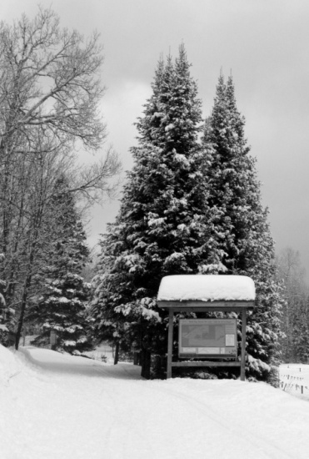

North Bay Nordic Ski Club

r website on the school calendar. To reserve a de, e-mail the school liaison.