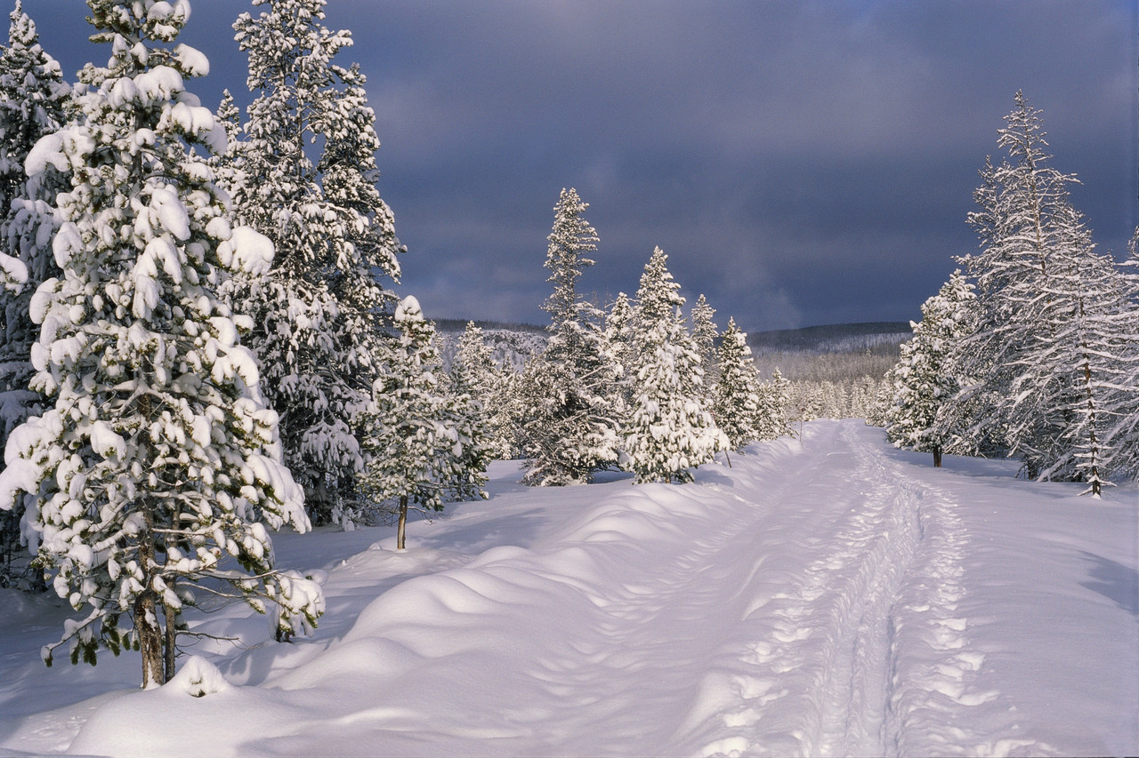***North Bay Nordic Ski Club Newsletter***

President’s Message by John Bowes

As I prepare myself to write these messages I like to do two things: read my messages from the previous year and get out on the trails to reflect on the season and what is to come. This year I could not get out on the trails, and I know this has been a challenge for many of us. Mother Nature is not working in our favour this season, she gave us a tease in November and we were all excited about the prospects of the coming winter wonderland. As quickly as it came, it was taken away. Reading my previous post from 2014, it seems I am always itching to get started, so I will hold my head high and look forward for what is yet to come.

As mentioned we were given a tease of snow early in the season. Our grooming team took advantage of these early season snowfalls to build a nice base on many of the trails. At this point in time we are set to go as soon as the snow falls. We have done a variety of trail maintenance over the summer and fall that will make a huge difference on many of our trails. A special thanks must go out to Kelly O’Grady, Peter Bullock and Rod Cloutier for all their hard work in the off season. I am looking forward to some great trails. We must also thank all our Adopt-a-Trail members for getting out to their section of trail to trim up the brush and make it easier for us to get the trails ready as soon as we can.

The club has been quiet over the holidays but will quickly explode with excitement as our members return. We have a growing number of Jack Rabbits and Bunny Rabbits this year which always adds to the club atmosphere. Many of our members have returned and new members and families have registered so we should see some new faces out there. If you meet someone new out there be sure to welcome them to the club and let them know about all our fantastic trails and members.

Prepare your skis, get your memberships taken care of (if you have not already done so) and clear your schedule so you are ready for that first sign of snow. We will keep you posted on trail conditions through our website and look forward to seeing everyone out there soon….very soon.

Ski Programs

We are very thankful for the snow that has fallen over the last few days so we can start our programs this **Sunday, January 4 at 1 pm**!  The trails are operational but do not have a thick base of snow. We may not have all trails open by Sunday.

All programs will start at the same time, 1:00 p.m., but will gather in different places.

**Bunny rabbits** will meet their instructors at the **Jackrabbit Lodge.** The instructors will have a class list and a sign so that it is easy for the children to find their instructor.

**Jackrabbits** will meet their instructors **down in the field.** They will also have a class list and a sign.

**Track attack** group will meet their instructor at the **Memorial Shelter** located at the gold/red/purple intersection.

All groups will get a snack during their class. Please be sure to let your child's instructor know if they have any food allergies or special needs. All children will get hot chocolate (with or without milk), a peanut free cookie and orange slices.

All families will be contacted by their instructor before classes begin on Sunday. There are some children that we have not placed in classes yet as we were not sure what level to put them in. Please come to see either myself or our new program coordinator, Brittany Nelson, on Sunday and we will help your child to find their class.

Bunny Rabbits will end at 2:30 and all other programs will end at 3:00 p.m. Please be sure that you are there in time to pick your child up and please let the instructor know that you are leaving with your child. For safety, children will not be able to leave their instructor until a parent or guardian arrives. If someone other than yourself is picking your child/children up please notify the instructor in advance.

If any parents are willing to help out with the program please contact Amy or Brittany by email at [northbaynordic@gmail.com](mailto:northbaynordic@gmail.com). If students would like to help out it can be used towards their volunteer hours at school.

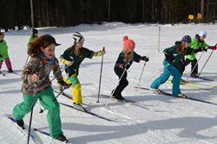Our goal for this year is to have fun, learn to ski or improve technique and be out on the trails! Please see Brittany or myself at any time if you have any questions, concerns or feedback.

See you on Sunday!

Amy Bartlett Gibson, Program Director

Brittany Nelson, Jackrabbit Coordinator



**ONTARIO SPECIAL OLYMPICS AT NORTH BAY NORDIC JANUARY 30 and 31, 2015**

On Friday January 30 North Bay Nordic will be hosting athletes competing to represent Ontario at the future Canadian Special Olympics. These athletes will compete in two or three of the following events. 100 m., 500 m., 1 km., 2.5 km., 5 km., 7.5 km. and 10 km. There will also be a 3 x 1 km relay if time permits on Saturday.

Preparation for the Olympics will begin on Monday January 25. First on the agenda will be the creation of a five lane 100 m track. This will be done by pushing snow into the east end of the parking lot. Parking will be limited. There will be military tents set up in the upper parking lot. These tents will be used by the athletes for lunch and by the 70 volunteers as a marshalling and dining area. Grooming a wonderful spectator friendly finish stadium will take place on Wednesday and finally on Thursday the flagging and fencing will be installed and we will be ready to go Friday morning and Saturday morning at nine.

The club house and snack bar will be open for business as usual during the week and during the event. Trails will not be affected until Friday. The toilets will be closed Friday and Saturday. Outdoor toilets will be located on the upper parking lot. The restriction on the trails is described below.

On Friday and Saturday most trails will be open for public skiing .The brown and yellow and the main trail to the memorial shelter will be closed. In order to use the purple and longer trails public skiers will use the gold trail and be marshalled through a short section to the memorial shelter. There will be short periods of time when the marshals will restrict public skiers on this section.

The snow shoe trail will be closed on Friday and Saturday.

Parking for the event is being handled as follows. All volunteers and spectators will be bussed to Nordic. Pickups will be scheduled at the Northgate mall. Parking attendants at Nordic and the local police will restrict parking to skiing guests and cars with parking permits only. Volunteers who car pool will be given parking passes. The city will be posting no parking on North Shore Rd. The police will be ticketing illegally parked cars.

But all this will be worthwhile. Nordic will be providing a great race environment for these athletes to experience our wonderful trails, our friendly race experienced team of club members and an opportunity to be recognized for their athletic performances. Many, many medals will be presented. Many proud parents will take oodles of photos at the awards ceremonies. This will be a special race weekend at Nordic.



Tom Cook

Nordic Co-ordinator

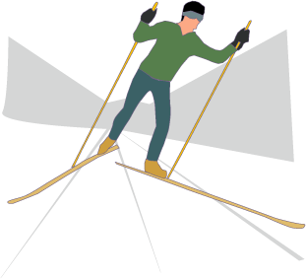

Did you know?

In Sapporo in 1972, Norway's Magne Myrmo became the last athlete to win a cross-country skiing event using all-wooden skis.



We are more than just bikes. Drop by to see our complete

selection of cross country ski equipment and Nordic clothing.

593 John Street 705-472-5662

North Bay, Ontario [www.cycleworksbikes.ca](http://www.cycleworksbikes.ca)

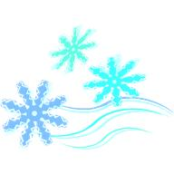

Where can you find the answers?



**It's all on our website –** [**www.northbaynordic.ca**](http://www.northbaynordic.ca)

**The Twitter feed provides you with the most up-to-date information on trail conditions and club activities.**

Races by Mike Ward

Happy New Year to all!

The snow is back, the trails are open, and we’re gearing up for another great race season.

As mentioned last month, there are many things happening in the race world this season. The annual Kiwanis Winter Triathlon will be returning Saturday, January 17. On January 30 and 31 we will be hosting the Ontario Special Olympics Winter Games followed by the Ontario University Athletic Association (OUAA) Championships February 13-15 and the Blue Sky Loppet February 22.

We are much honored to be hosting the Nordic event for the Special Olympics. As this is a high profile event there will be restrictions for parking and use of the clubhouse upstairs on January 30 and 31. Please stay tuned to our Twitter feed and future News Blasts for updated information. We appreciate your support and understanding as we work hard to contribute to this incredible event.

 Our race committee is seeking volunteers for both the OUAA Championships (February 13-15) and the Blue Sky Loppet (February 22). Even helping out with one day (~4 hours) of an event would is incredibly helpful and appreciated. Positions are available as course marshals, timing crew, stadium crew, and registration. Come on out and see the action firsthand! If interested contact Mike Ward at [naturemike@gmail.com](mailto:naturemike@gmail.com).

See you out on the trails!

Racing teaches us to challenge ourselves.

It teaches us to push beyond where we thought we could go.

It helps us to find out what we are made of.

This is what we do.

**This is what it’s all about.**

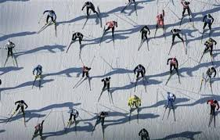

Treasurer’s Report by Gary Jodouin

**The Treasurer’s report is included as an attachment to this email. You can open it the same as you did for the newsletter.**

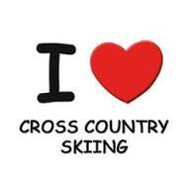

*Question: What do Michael Phelps, Carl Lewis and Bjorn Daehlie have in common?*

*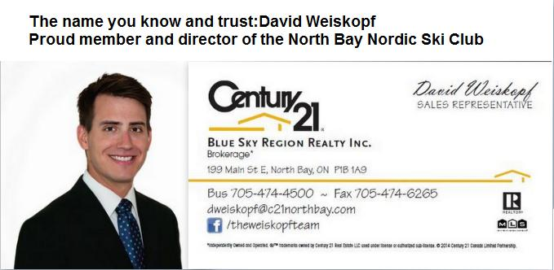Answer: They are among the most prolific gold medalists ever at the Olympics*.  
*If you asked: who is Bjorn Daehlie, then you're probably in the majority and also probably not a cross-country ski fan.   
Daehlie is a Norwegian skier who many consider the best winter athlete of all time, having won a total of eight Olympic gold medals between 1992 and 1998, and 12 medals in total.*

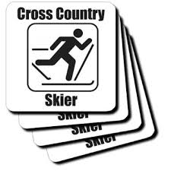

In Memoriam

**Jack Wootton**

Jack was an early skier and ski racer on the North Bay scene. Racing included all disciplines from downhill to cross country to slalom and sometimes ski jumping! And to top it off it was all done on one pair of skis!! (“Kick and Glide” A History of the North Bay Nordic Ski Club).

In the late 1970’s he switched solely to cross-country and the Nordic scene.

Jack was on the Board of Directors from 1980 to 1983 with the portfolio of trails. He worked diligently with fellow members building the trail system.

He was a long time member and loved the sport.

He will be missed.

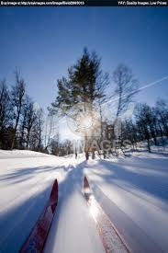



In Memoriam

**Jackie Goulet**

Jackie skied with the Laurentian Touring Club in the early 1970’s. They skied on backwoods trails and were always looking for new areas to ski.

The Laurentian Touring Club merged with the Nordic Ski Club and became the North Bay Nordic Ski Club in 1975.

Jackie was on the first Board of Directors and remained on the board from 1975 to 1981. She was one of the first qualified ski instructors at the club and taught skiing for many years.

She was involved in ski exchanges, socials, publicity and ski instruction.

We are grateful for her many contributions to the club.

North Bay Nordic

Junior Racing Team

Hurry get your tickets, event was SOLD OUT last year!

GOURMET MEAL AND SILENT AUCTION

Saturday, January 17/North Bay Nordic Ski Club at 6 p.m.

**JRT GOURMET ITALIAN FOUR COURSE MEAL INCLUDES:**

**SOUP, SALAD, FRESH BREAD, GOURMET PASTA DISH AND DELECTABLE DESSERTS**

**SERVED WITH TEA AND COFFEE**

**(GLUTEN FREE AND VEGETARIAN OPTIONS WILL BE AVAILABLE)**

**PLEASE BRING YOUR OWN NON-DISPOSABLE TABLE SETTING.**

$30 per person Take-out option available

Tickets available at the North Bay Nordic Ski Club snack bar.

For further information please contact:

Sophie Blain-Rogers at 705-303-5327 or email at [joey.sophie@live.com](mailto:joey.sophie@live.com)

Tanya McCubbin at 705-495-4166 or email at [greencanoe121@gmail.com](mailto:greencanoe121@gmail.com)

COMING EVENTS / IMPORTANT DATES

Sunday, January 4 First day of Jackrabbit lessons 1:00 p.m.

Saturday, January 17 Kiwanis Winter Triathlon 9:00 a.m. start

JRT Pasta Extravaganza 6:00 p.m. at the clubhouse

Saturday, January 24 Club’s 39th Anniversary 2:00 pm at the clubhouse

January 30 – 31 Special Olympics Ontario .

Winter Games

Saturday, February 14 Valentine’s Social

Sunday, February 15 OUA Race at the Nordic

Sunday, February 22 Blue Sky Loppet

Sunday, March 8 Last day of Jackrabbit lessons 1:00 p.m.

Easter Egg Hunt 2:30 p.m.

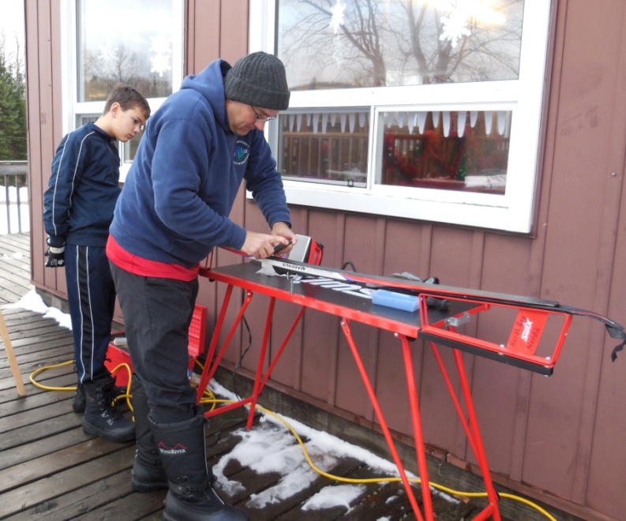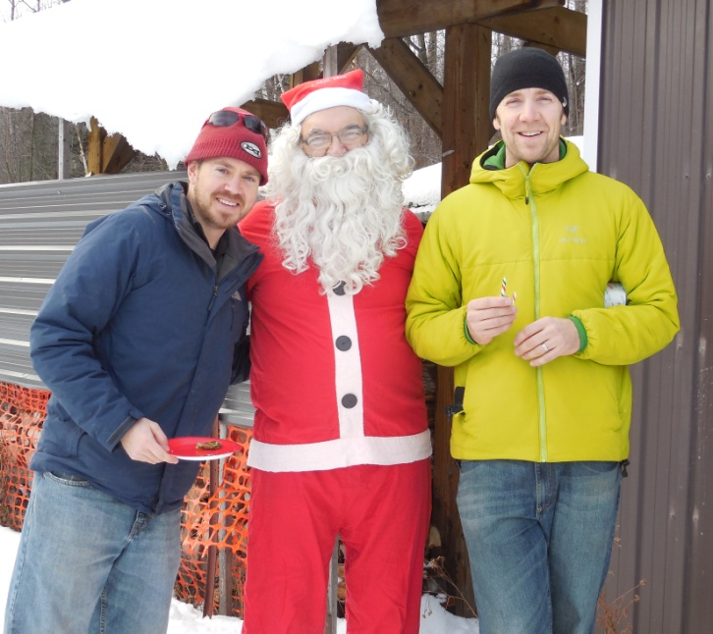

**FUN AT THE OPEN HOUSE**

Mike Ward Santa John Bowes Andrew Koski-Harja waxing skis at the Open

Races A.K.A. Treasurer President House assisted by his son, Erik.

Gary Jodouin

Cross Country Skiing Vocabulary Mix and Match

Can you match the Nordic ski terms to the correct definition? The answers will be on the bulletin board at the ski club!

Klister The upward curve built into the middle of the ski.

Telemark An indentation in the snow left behind by a fallen skier.

Glide Wax The bottom of the ski where wax is applied.

Waxless Skis The stiffness of the ski.

Camber A super sticky version of kick wax for extremely crazy snow conditions.

Kick Wax Any type of skiing in which the heel of the boot is not attached to the ski.

Sitzmark Type of skiing where one ski slides forward with a forward bent knee position to turn while going down a hill.

Flex Skis with a small ridge of patterns on the kick zone providing grip without the use of kick wax.

Nordic Skiing A wax applied to the middle part of classic skis to increase friction between the ski and the snow.

Base Wax applied to the base of the ski which decreases friction between the ski and the snow.

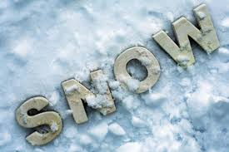Board of Directors

John Bowes *Please*

**President**

Tom Cook

**Vice-President; Building and Property**

Gary Jodouin

**Treasurer**

David Weiskopf

**Membership**

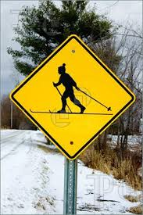

**Kelly O’Grady**

**Trails**

Julie Bass

**Newsletter/Publicity; Socials**



Mike Ward

**Races**

Erin Fettes

**School Liaison**

**Amy Bartlett-Gibson**

**Ski Programs**

**Board members can be contacted by email at:** [**info@northbaynordic.ca**](mailto:info@northbaynordic.ca)

