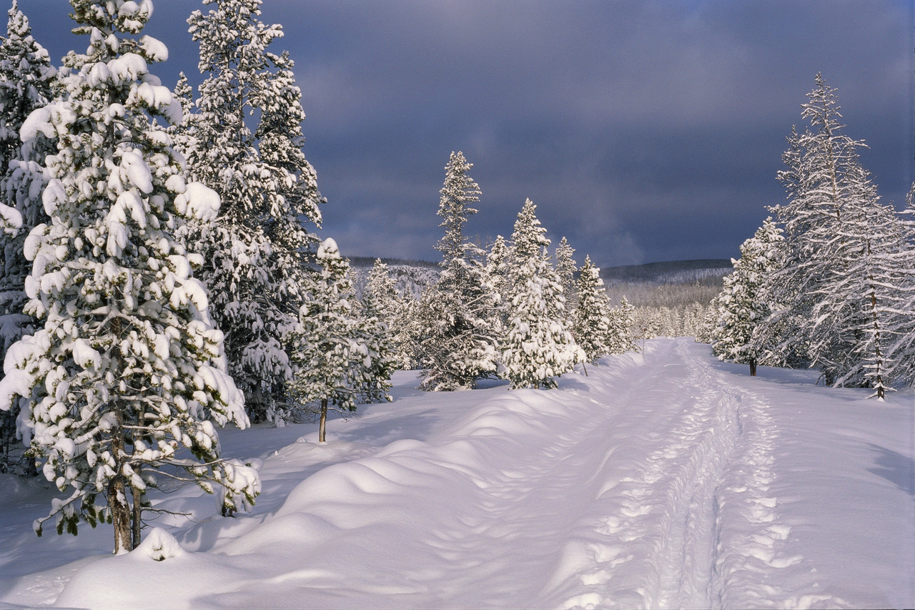
North Bay Nordic Ski Club News Blast

2015 Special Olympics Ontario Winter Games
Congratulations North Bay Nordic – you rock!
The games were a big success. Everyone had a great time and Nordic has received many, many complements.
Special thanks go to Tom Cook, the Venue Manager and Chief of Race, and Dave Minden, the Chief of Course. The club was totally transformed. Athletes, coaches, volunteers, spectators and VIP’s descended upon the club for two spectacular days of competition, laughter and fun.
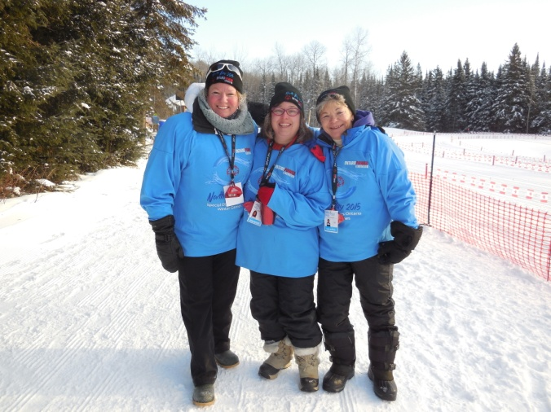
Photos of the event can be found on our website – www.northbaynordic.ca . Look under the “more” heading; go to “events” and then to “recent events”. Additionally, a photo album has been prepared for the clubhouse.
Here are a few samples:

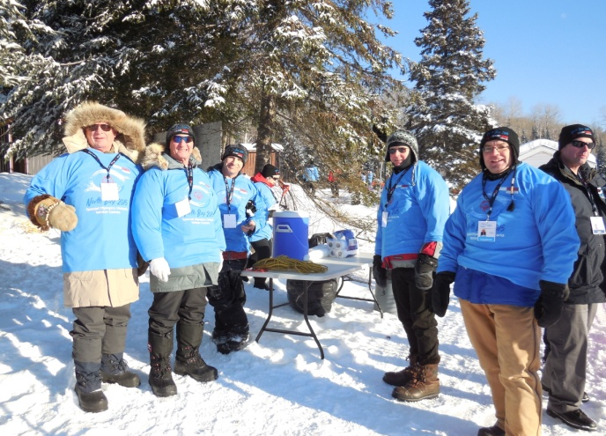
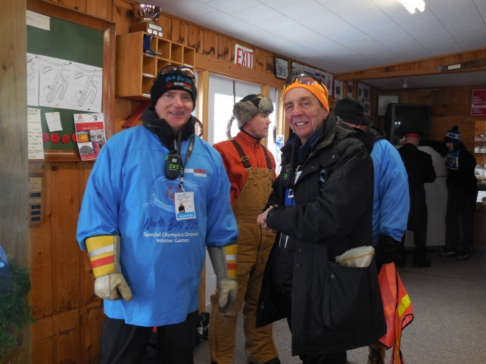

Love is in the air.
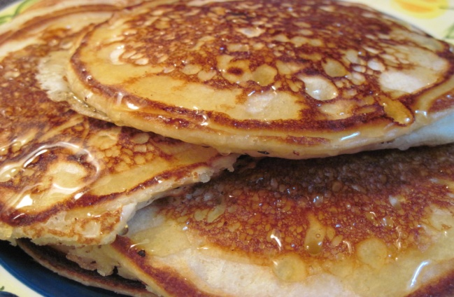
Pancake Brunch
Saturday, February 14
9:30 a.m. to 12:30 p.m.
Pancakes & Sausage
Fruit
Hot Beverage
$6 for adults / $3 for children

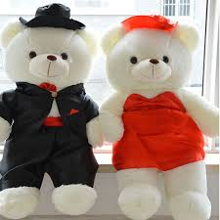
Dress up for Valentine’s Day and receive a prize!

There will be Valentine
crafts for kids.

As an added thank you to our Special Olympic volunteers, wear your identification lanyard to the Pancake Brunch and get 50% of the price.
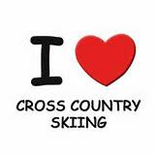

Upcoming Coaching Courses
North Bay Nordic and Cross Country Ontario are offering an Introduction to Community Coaching and Community Coach workshop the weekend of March 6, 7 and 8th, 2015. The course is intended for instructors or anyone who is interested in getting their community coaching certification. High school coaches, potential Jackrabbit coaches for next season... If you are interested in teaching Bunnyrabbits you require the Community Coaching certification. To teach Jackrabbits and Track Attack both Community Coaching and Introduction to Community Coaching certification is required.
The Community Coaching course is more theory and the Introduction to Community Coaching course is more practical. There are six hours of snow training (ICC) – three for classic and three for skate skiing.
The link below will take you to the Zone 4 registration for the workshops being held at North Bay Nordic. Please fill in all the information requested, you can pay by credit card for the course. The cutoff date for registering for the workshop is March 4th, 2015. The courses are $125 each.
Link for Zone 4 registration: https://zone4.ca/reg.asp?id=8646&lan=1&cartlevel=1
The course will run Friday, March 6 - 6:00 to 9:30 pm; Saturday, March 7 - 8:30 am to 6:00 pm and Sunday, March 8 from 8:30 am to 4:30 pm.

Ontario University Athletic Association Championships
February 13-15
The OUAA Championships are back! This year they are happening at three different locations: Laurentian Ski Hill, Nipissing University, and North Bay Nordic Ski Club. Come out and see the action as the top varsity skiers in the province battle for gold!
For more information go to: http://www.tourdenipissing.com
Schedule of Events:
Friday, Feb 13 Laurentian Ski Hill
Skate Team Sprints 5:30 – 7:30 p.m.
Saturday, Feb 14 Nipissing Trails 6.6 km Classic 11 a.m. – 1 p.m.
Sunday, Feb 15 North Bay Nordic 10 km Skate
9 a.m. – 12 p.m.

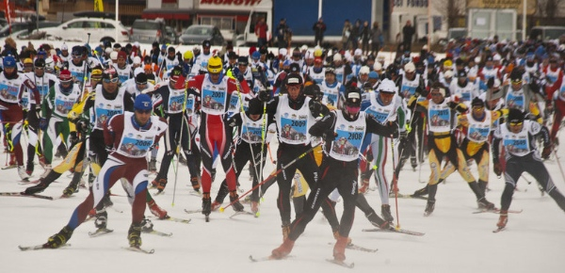

Blue Sky Loppet 2015
Sunday, February 22

Come on out and join the crowds for our annual Blue Sky Loppet.
Challenge yourself to a longer distance, or just come skiing with a friend!
There will be distances of 3, 8, and 18 km both in classic and skate ski techniques.
Races will begin at 10 a.m.
There will be Jackrabbit races of 0.5 km and 1 km at 12 p.m. Participants in the club’s Jackrabbit program can enter for FREE!

There will be lots of great prizes.

$25 Entry Fee for 8 and 18 km races.
$5 Entry Fee for 3 km races.

Registration for the 3 km, 8 km and 18 km races will be on the North Bay Nordic website in the next few days.

Come on out and ski with us!

