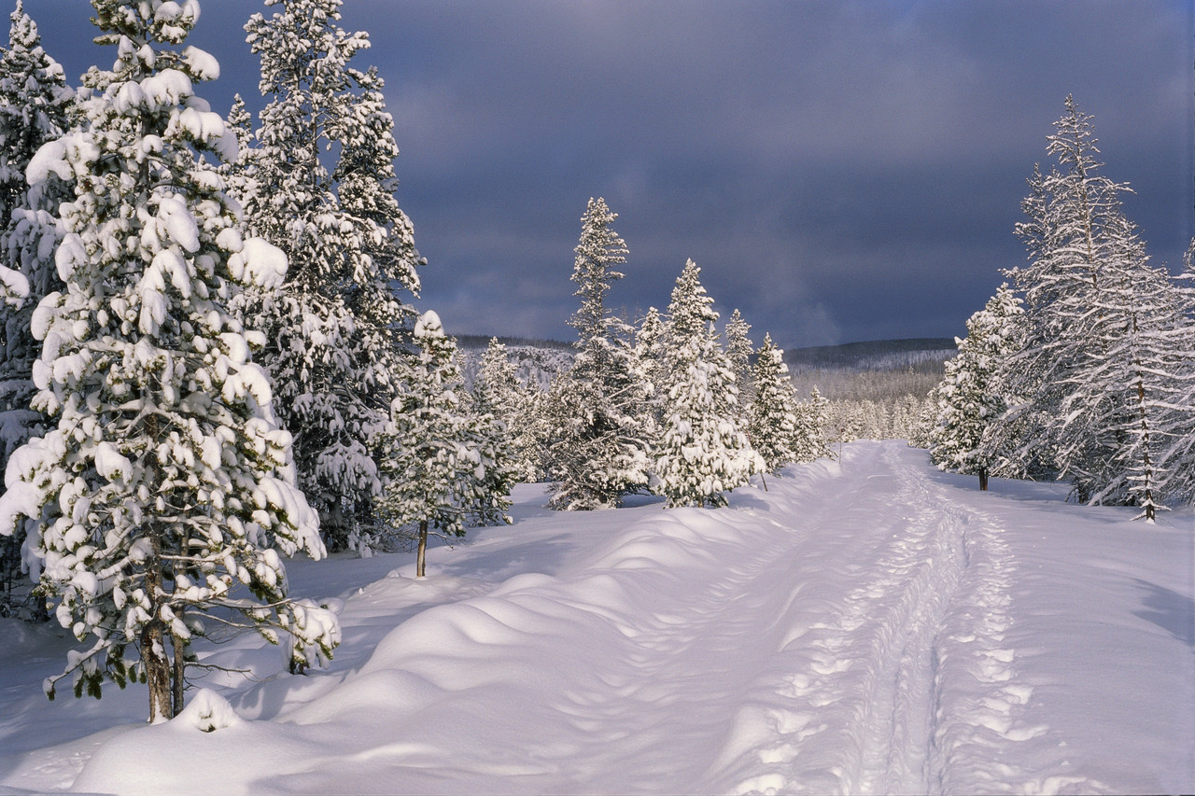
North Bay Nordic Ski Club Newsletter

SPECIAL OLYMPICS ONTARIO WINTER GAMES AT NORTH BAY NORDIC JANUARY 30 and 31.

On Friday, January 30 and Saturday, January 31, North Bay Nordic will be hosting athletes competing to represent Ontario at the future Canadian Special Olympics. These athletes will compete in two or three of the following events: 100 m., 500 m., 1 km., 2.5 km., 5 km., 7.5 km. and 10 km. There will also be a 3 x 1 km relay if time permits on Saturday.
Preparation for the Olympics will begin on Monday January 26.
- First on the agenda will be the creation of a five lane 100 m track. This will be done by pushing snow into the east end of the parking lot. Parking will be limited.
- There will be military tents set up in the upper parking lot. These tents will be used by the athletes for lunch and by the 70 volunteers as a marshalling and dining area.
- Grooming a wonderful spectator friendly finish stadium will take place on Wednesday.
- On Thursday the flagging and fencing will be installed.
We will be ready to go Friday morning and Saturday morning at nine a.m.
During the week of January 26-29:
Please do not park in the upper parking lot or near the fence in the lower lot.
Use the lot on the other side of the road.

The club house and snack bar will be open for business as usual during the week and during the event.
The toilets in the clubhouse will be closed on Friday and Saturday; however, outdoor toilets will be located in the upper parking lot.

Trails will not be affected until Friday.
The restriction on the trails is described below:

- On Friday and Saturday most trails will be open for public skiing.
- The brown, yellow and the main trail to the memorial shelter will be closed.
- In order to use the purple and longer trails, public skiers will use the gold trail and be marshalled through a short section to the memorial shelter.
- There will be short periods of time when the marshals will restrict skiers on this section.
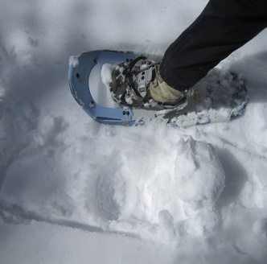

The snow shoe trails will be closed
on Friday and Saturday.

Parking for the event is being handled as follows:
- All volunteers, spectators and public skiers will be bused to North Bay Nordic.
- Pickups will begin at 9 a.m. on Friday and Saturday mornings at Northgate Square across from Sears and will continue every hour until 4 p.m.
- Buses will return from North Bay Nordic on the half hour from 9:30 a.m. to 4:30 p.m.
- There will be parking available at the club after 4 p.m. and night skiing on Friday evening.
- Parking attendants at North Bay Nordic and the local police will restrict parking to guests and cars with parking permits only.
- The city will be posting “No Parking” signs on Northshore Road. The police will be ticketing illegally parked cars.
So if you want to ski on Friday or Saturday enjoy the bus ride!

But all this will be worthwhile. The North Bay Nordic will be providing a great race environment for these athletes to experience our wonderful trails; our friendly, experienced race team of club members, and an opportunity to be recognized for their athletic performances. Many, many medals will be presented and many proud parents will take oodles of photos at the awards ceremonies. This will be a special race weekend at North Bay Nordic.

Come out and support these Special Olympians.

