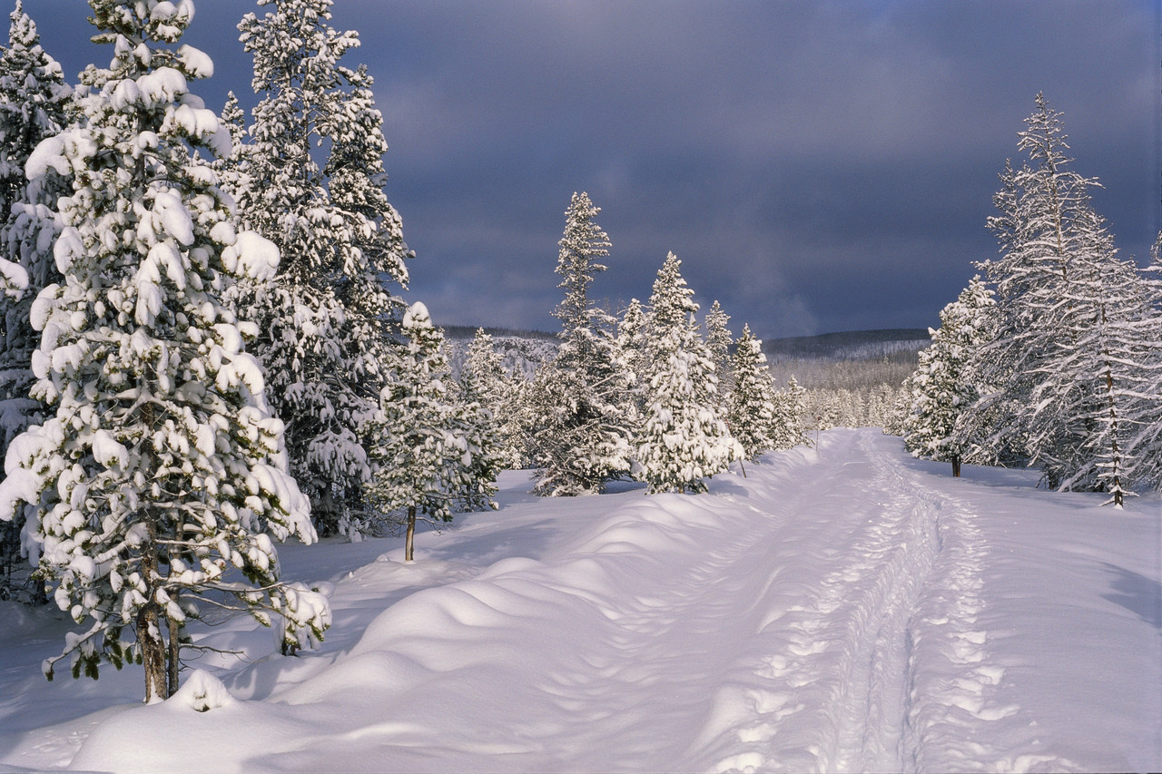***North Bay Nordic Ski Club Newsletter***

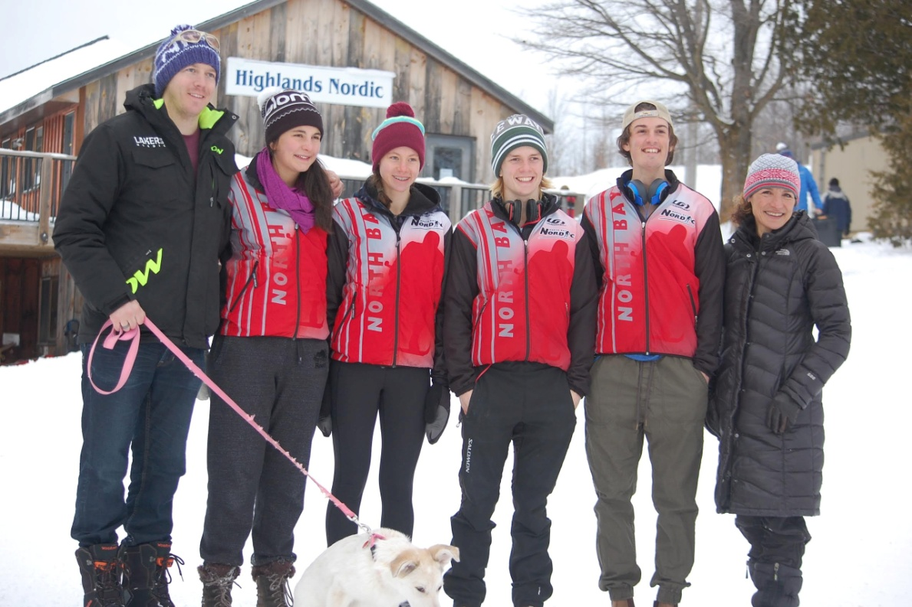Meet the Junior Racing Team

Left to right: Dave Nighbor (Assistant Coach), Hannah Story-Korman, Olivia Wolfram, Hudson McCubbin, Mikell Blain-Rogers, Sera Tempio (Head Coach)

Junior Racing Team Results at Ontario Cup Race

The North Bay Nordic Junior Racing Team participated in their first Ontario Cup races of the season at Highlands Nordic in Duntroon from January 8 to 11, 2015. These races were not only for Ontario athletes, but for skiers all across Canada, including some National Team members. Skiers came hoping to qualify for the World Juniors as well.

The first two days involved classic technique races: an interval distance race on Thursday and a sprint race on Friday. The weekend concluded with a freestyle/skate race.

Team member Hannah Story-Korman, a second year juvenile girl from Temiskaming Shores, won a bronze medal in the distance classic. Hannah narrowly missed the podium two other times with a fourth place finish in the classic sprint final, and a fourth place finish in the distance skate race. This is Story-Korman’s first year with the North Bay team and she is also a member of the Ontario Talent Squad.

Teammate and juvenile girl, Olivia Wolfram, in her first year of racing, fought hard, ending the weekend with a twenty-first place finish in a field of the country's best racers.

Juvenile boy and Ontario Talent Squad Member, Hudson McCubbin, had 3 top 10 performances, including a fifth place finish in the distance classic, a ninth place finish in the sprints, and a sixth place showing in the distance skate race.

Mikell Blain-Rogers, a second year Junior boy, made huge improvements this year with 2 top 10 performances in a very competitive field. Blain-Rogers successfully reached his first final heat in the classic sprints, ending up fifth in the B final.

The Junior Racing Team heads to the Eastern Canadian Championships from January 29 to February 1 and O Cup 3 in Timmins from February 28 to March 1.

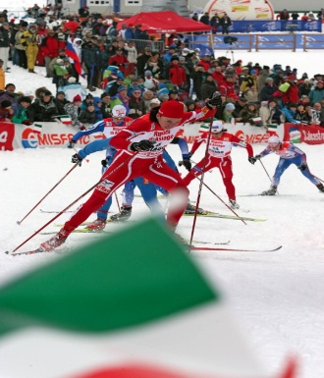 The team is hosting a pasta dinner at the North Bay Nordic Ski Club on Saturday, January 17 to raise funds for the National cross country ski championships in March. Tickets are available at the North Bay Nordic Ski Club snack bar or from any team member.

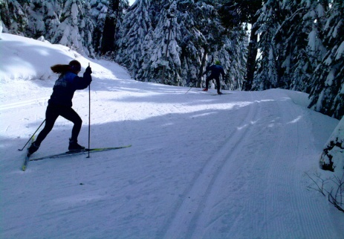

North Bay Nordic

Junior Racing Team

Hurry get your tickets, event was SOLD OUT last year!

GOURMET MEAL AND SILENT AUCTION

Saturday, January 17/North Bay Nordic Ski Club at 6 p.m.

**JRT GOURMET ITALIAN FOUR COURSE MEAL INCLUDES:**

**SOUP, SALAD, FRESH BREAD, GOURMET PASTA DISH AND DELECTABLE DESSERTS**

**SERVED WITH TEA AND COFFEE**

**(GLUTEN FREE AND VEGETARIAN OPTIONS WILL BE AVAILABLE)**

**PLEASE BRING YOUR OWN NON-DISPOSABLE TABLE SETTING.**

$30 per person Take-out option available

Tickets available at the North Bay Nordic Ski Club snack bar.

For further information please contact:

Sophie Blain-Rogers at 705-303-5327 or email at [joey.sophie@live.com](mailto:joey.sophie@live.com)

Tanya McCubbin at 705-495-4166 or email at [greencanoe121@gmail.com](mailto:greencanoe121@gmail.com)

