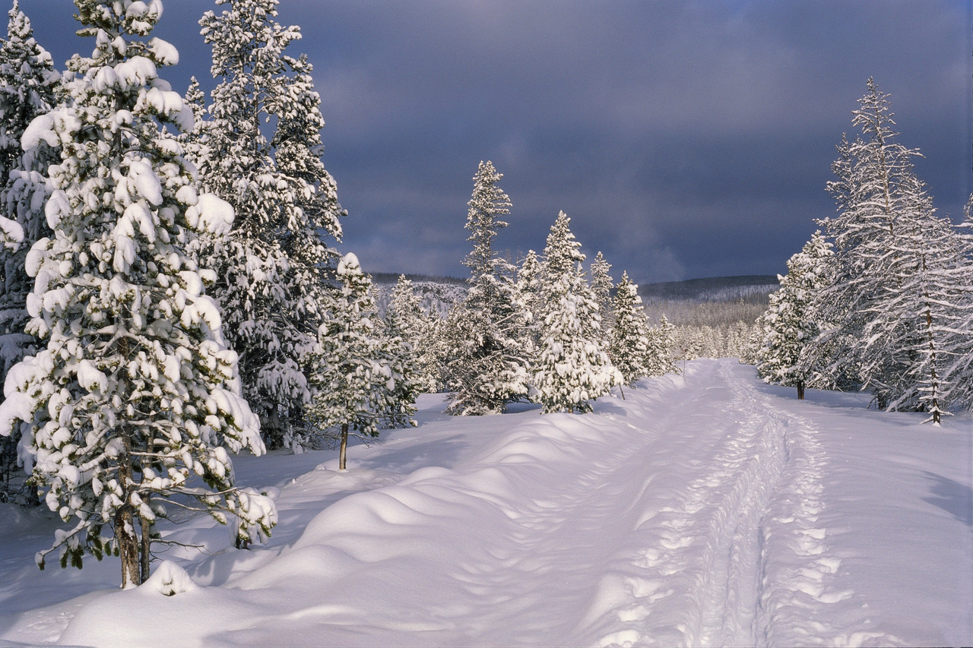***North Bay Nordic Ski Club Newsletter***

President’s Message by John Bowes

I hope everyone out there has had a wonderful summer. It was a chilly and wet one this year but we did have some great days. Now it is time to look forward to all the fun in the sun we will have on the snow. I am pleased to inform everyone that I will be continuing on as the North Bay Nordic President. I enjoyed the experience last year and am excited for another fantastic season with the club.

I thought it was worthwhile to head out on the trails this afternoon for a light trail run. I like to get a good feel for the trails again and reflect on our last winter. It brought back memories of Jackrabbits in the field; morning skis around the green trail, and all the friendly faces of our membership. I saw evidence of our Adopt-A-Trail program in full swing; fall maintenance efforts around the clubhouse, and even some trail improvements. We have been working hard throughout the off-season to jumpstart the club and be ready for the snow as soon it falls.

I am excited to announce that all Board of Director positions have been filled for this year. Tom Cook has stayed on with Building & Properties, as well as Vice-President. We also have Gary Jodouin continuing as the Treasurer, Erin Fettes as School Liaison, David Weiskopf on Membership, Mike Ward on Races and Julie Bass on Newsletter and Publicity for the club. We have two new faces joining us as well, Amy Bartlett-Gibson has taken over Ski Programs and Kelly O’Grady is on Trails. We welcome them both officially to the Board and look forward to working with them this year. Both Kelly and Amy have stepped up to their roles and we have been very impressed with their contributions to the club.

C:\Documents and Settings\Julie Risling\Local Settings\Temporary Internet Files\Content.IE5\E3ZEDV6N\MC900021628[1].WMFAs always, I am excited for the upcoming season. It was when I lost my running shoe in the mud that I thought to myself, “this is why I ski!” We had a great season last year and many folks took advantage of the snow until the bitter end. I had reports of people out on the green trail chasing moose and bears in late April. We have made some substantial improvements to the trails that will improve the quality of skiing and extend our season even further. It should be a fantastic season. I thank all those that have been involved with the club and look forward to seeing everyone again out on the trails soon.

C:\Documents and Settings\Julie Risling\Local Settings\Temporary Internet Files\Content.IE5\E3ZEDV6N\MC900021628[1].WMF

C:\Documents and Settings\Julie Risling\Local Settings\Temporary Internet Files\Content.IE5\E3ZEDV6N\MC900294362[1].WMFRacing News by Mike Ward

Hello North Bay Nordic members!

It gives me great pleasure to be returning this year as Race Director!

There are a number of exciting events coming to our ski club this season, so

keep your eyes open for the excitement!

**January 17: Kiwanis Winter Triathlon**

Ski, snowshoe, and run through this triathlon event. Go as a team or try it by yourself!

**January 30 – 31:** [**North Bay 2015 Special Olympics Ontario Winter Games**](http://www.google.ca/url?sa=t&rct=j&q=&esrc=s&source=web&cd=1&cad=rja&uact=8&ved=0CB8QFjAA&url=http%3A%2F%2Fwww.specialolympics2015games.com%2F&ei=jWwpVLvRI4H2yQTAh4DQCg&usg=AFQjCNHb595bX8y-FRst5Xya8m7Lzf4qyA&sig2=UVL98-rH7cHBrE_U1GNarQ&bvm=bv.76247554,d.aWw)

North Bay is fortunate to be hosting this remarkable event, and North Bay Nordic is honoured to be hosting the Nordic skiing competitions. Come out to the club and cheer on athletes from across the province!

**February 13-15: Ontario University Athletics (OUA) Championships**

Varsity level Nordic teams from around the province will be coming to North Bay to compete for the OUA title. Be sure to come on out and watch the races as this will be a spectacle you won’t want to miss. The morning of Sunday, February 15 is the only race that will take place at the club.

**February 22: Blue Sky Loppet**

This year’s Blue Sky Loppet will be focused on getting our members out to participate in this exciting event. We are planning a one day family friendly loppet. Come on out with friends and family of all ages, and join the group! Have you ever wanted to ski the 18 km Green Trail? Well here is a great opportunity! Other distances will also be available. More information to come closer to the date.

**Other nearby events:** Muskoka Loppet – Sunday, January 25

Temiskaming Loppet – Early February

Exact dates of events will be posted on our website as they are announced closer to the season. Come on out and join in as a participant, volunteer or a member of the cheering squad!



See you around the club.

[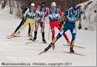](http://www.google.ca/url?url=http://socorpos.blogspot.com/2011/04/cartoon-cross-country-skier.html&rct=j&frm=1&q=&esrc=s&sa=U&ei=PIEpVLmgCYX_yQTV94HYCQ&ved=0CDEQ9QEwDjg8&usg=AFQjCNF5YvJ5QhB1bkKWcaPnKKcSqvd-VQ)

C:\Documents and Settings\Julie Risling\Local Settings\Temporary Internet Files\Content.IE5\XCOZZM20\MC900105218[1].WMFSummer Trail Work by Kelly O’Grady

It has been a challenging summer on the trails. The MNR came through with some approvals for trail work September 1. With the help of John Bowes and Peter Bullock we were able to get permission to change out five culverts and reset two. We were also able to fix some wet spots on the trail system. On the climb just before the 6 km marker on green, the trail has been moved over to get away from the creek that was running down the middle of the trail. Although we were unable to complete all the work we were hoping to do this summer, the worst spots did get done and should make a big difference for grooming this winter.  Many thanks to Peter Bullock, Joe Lynch and Bruce McIvor for coming out and volunteering to do the hard physical work to get the trail repairs done so quickly.

Building and Property Report by Tom Cook

Over the past few weeks changes have occurred at the club house. The ladies in the canteen will be pleased to know that a new sub floor and floor tiles have been installed in the snack bar.

A new cabinet to be installed under the microwave will be used for condiments and relieve some of the congestion around the snack bar.

The water filter will be changed to a back wash filter. This should reduce the

number of times we lose the water due to the filter being plugged. Our water is

tested regularly and always proves to be drinkable.

The deck renovations have been postponed until next year as an engineering

design is required and we will not be able to get a building permit in time to start

work this fall.



We are more than just bikes. Drop by to see our complete

selection of cross country ski equipment and Nordic clothing.

593 John Street 705-472-5662

North Bay, Ontario [www.cycleworksbikes.ca](http://www.cycleworksbikes.ca)

C:\Program Files\Microsoft Office\MEDIA\CAGCAT10\j0299587.wmf

C:\Program Files\Microsoft Office\MEDIA\CAGCAT10\j0299587.wmf

School Liaison Report

We are looking forward to another busy season for our school programs. Schools can buy a yearly membership for only $100 which allows any of its students to use the trails during the day when accompanied by a teacher. Equipment rentals are available at a reasonable rate.

Skiing is an excellent option for a full class trip to help introduce new skiers to the sport. Alternatively, many schools offer cross-country skiing as a choice during their winter electives. There are also three organized events for elementary school age students to help introduce the children to the trails; challenge the students to ski longer distances, and participate in friendly competition.

If you are a teacher, please see our website for more information and for available dates. If you are hesitant about bringing a full class of students, and would like instructors to help teach and organize your kids, check out the following website [www.natureandyou.org](http://www.natureandyou.org). My class was *still* talking about their skiing experience with Mike from “Nature and You” when June arrived.

If you are a parent of a skier who would like others to have the chance to try cross-country skiing, talk to your child’s teacher or school principal about the opportunity. If you could also volunteer to help the teacher on the day of the activity, I’m sure it would be much appreciated.

I’m looking forward to seeing many smiling students’ faces out on our trails. Please do not hesitate to e-mail me if you have questions.

**By: Erin Fettes**

**Help Wanted**

Are you a shutterbug?

We want pictures of the activities and adventures happening at the club so we can include them in the newsletters.

From races to social events to beautiful trail shots we would appreciate them all.

E-mail your pictures to Julie Bass at [jbass@cogeco.ca](mailto:jbass@cogeco.ca).

C:\Documents and Settings\Julie Risling\Local Settings\Temporary Internet Files\Content.IE5\5R1RY5N5\MC900437565[1].WMF



Adopt a Kilometre Program

The adopt-a-km program was initiated by Tom Cook when he was the Trail Director in 2004.  The idea was a copy of the adopt-a-section program of highways we see in Ontario.  Tom approached club members and got their commitment to take on a km.  This commitment gives members a sense of ownership, pride and a bit of pressure since their name is on the section and if it has not been done one can suffer teasing.

Adopting a section means that you are to clear one kilometre of trail of the previous summer’s growth of small saplings and raspberry cane.

 It is best that the adoptee finds two or three friends or family members to help brush the section.  With four brushers it will take about four hours to do a kilometre. The club provides the power brush cutters and safety equipment.  There is also pole cutter to clear overhead branches that interfere with the groomer.  Large dead fall is left to be removed by trained chainsaw operators.  Small branches and stones are removed by the adoptees.  The summer growth down the middle of the trails will have been cut by the drag behind the brush

hog early in September.  Both sides of the trail need to be brushed by the adoptee. The brushing equipment is available to the members in the waxing room.  Safety

training is available from the Directors.

[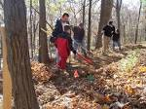](http://www.google.ca/url?url=http://www.greenways.org/trailworkdb/CompletedPage2.asp&rct=j&frm=1&q=&esrc=s&sa=U&ei=-gMWVPj7IcaGyATFroK4Cw&ved=0CBUQ9QEwADgU&usg=AFQjCNGU8covD4coAhNMQQWHe2ly8f1WbA)

To recognize the adoptees' contribution, the club erects a sign of appreciation at the start of the kilometre.  Each year the trails committee looks to have every kilometre adopted.  There are 24 sections adopted each year. If you would like to adopt-a-kilometre please contact John Bowes ( [bowesjd@gmail.com](mailto:bowesjd@gmail.com)) for further information.

C:\Documents and Settings\Julie Risling\Local Settings\Temporary Internet Files\Content.IE5\E3ZEDV6N\MC900021628[1].WMF

*We’re on the Web!*

*Visit us at:*

www.northbaynordic.ca

[](http://cco-test-stoer.myshopify.com/collections/bunnyrabbit)Ski Programs by Amy Bartlett-Gibson

**Programs**

As fall is upon us we are busy reflecting on last year and setting up for another successful season at the club. There are some new things happening in programs this year.

**Playground**

Under the direction of David Weiskopf we have set up a playground on the Jackrabbits field. The playground will have one large mounded hill and a bank. We are hoping that this will make the field a more dynamic place for kids and adults to play around, but also that instructors will be able to use these areas for teaching. There is a link below to a video created by Cross Country Ski Canada demonstrating a very exciting playground out west! Something to aspire to. We may need some volunteers willing to shovel if we are going to achieve something similar!

Here is the link: <https://www.youtube.com/watch?v=0EDew_65Lgw>

**Coordinator and Leaders**

There will be some changes to our programs this year. Sadly Sandy Hodgins our Track Attack leader has moved on. Sandy did a great job of leading the Track Attack program; we thank him for all his hard work and dedication, and wish him all the best. We will be searching for a new leader for the 2014 Track Attack program. We are also advertising for the program coordinator position. Please direct interested applicants to our website for more information before the closing date on October 14, 2014. Finally, we will be recruiting new and past Jackrabbit and Bunny Rabbit instructors soon. If you are interested in instructing again or know of someone who would like to instruct for the first time this year be sure to contact us at [northbaynordic@gmail.com](mailto:northbaynordic@gmail.com). Please leave your name and phone number so we know how to reach you.

**Development Team News…**

The North Bay Nordic Junior Development Team, or Devo Team, is a program geared towards skiers aged nine to fourteen who are interested in racing.  Younger skiers should have completed Level 4 Jackrabbits, while older skiers should be very comfortable on their skis.  The Devo Team focuses on **skill development, technique, race experiences and fun**.

The team is coached by Andrew Koski-Harja and Mike Ward.  Both are former junior and university racers and very involved with the Nordic Ski Club in various roles.

The dry land training program started on **Sunday September 28 from 12 noon-1:30 pm at the Nordic Club**.

Training sessions this fall will be on Fridays and Sundays.  The start times for these sessions are flexible.  I would like to start the Friday sessions at 3:45 pm.  Most of the fall Friday sessions will be at Chippewa Secondary School.  Sunday sessions will start at 12 pm at the Nordic Club.  We can adjust these times if they do not work for everyone.  Once we have reliable snow, Friday practices will switch to the Nordic Club, with perhaps a later start time.

Please let me know if your child is interested in being on the team this year.  Also, if you know of any other athletes who might like to be involved, please forward this email and my contact information to them.

Although dry land training has started, the Development Team is always welcoming of new members. If you are interested contact;

Andrew Koski-Harja

[andrew_koski-harja@sympatico.ca](mailto:andrew_koski-harja@sympatico.ca)

705-474-0478

We look forward to another exciting year at the club,

See you out there!

More on the Ski Playground

I have never been more excited for an upcoming ski season as the one right around the corner! After at least 20 years of skiing, I feel that I have re-found my passion for skiing and couldn’t be more amped! Skiing should be fun and not just an amazing workout. Throughout the years of skiing as a junior, coaching and now being a board member, I have noticed that many mid aged children are not “excited” to ski. I am not alone in this feeling, and in recent years Cross Country Canada has been pushing to turn up the “fun factor” for children while all along improving skier abilities. Hence the creation of “Ski Playgrounds” or “Terrain Parks”. CCC defines this as: “A ski playground is a designated location which has been developed or set up to assist children to learn to ski naturally, and which provides a variety of skiing discoveries. A Ski Playground should provide a variety of terrain that will help develop a child’s balance and coordination skills." I am pleased to announce that North Bay Nordic will be implementing phase 1 of a ski playground located in the field for this upcoming ski season. The ski obstacles have been placed in a way as to not affect Jackrabbits, lessons or races and should be lots of fun for all levels of skiers. The Board of Directors would love to hear your comments and suggestions on how to improve this area of our club for future years.

**By David Weiskopf**

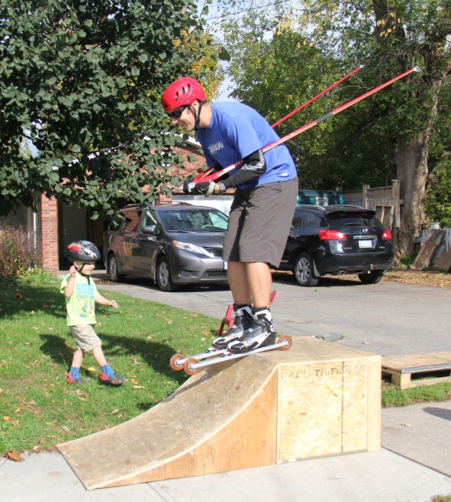 **“Getting pumped for the new ski**  **playground!”**

Find us on Facebook

Follow us on Twitter

C:\Documents and Settings\Julie Risling\Local Settings\Temporary Internet Files\Content.IE5\XCOZZM20\MC900434635[1].WMFComing Events/Important Dates

Friday, November 21 Bring your used equipment for

the ski exchange to the clubhouse.

4:00 – 7:30 p.m.

Saturday, November 22 Ski Exchange and Sale

9:00 a.m. – 12:00 p.m.

C:\Documents and Settings\Julie Risling\Local Settings\Temporary Internet Files\Content.IE5\E3ZEDV6N\MC900434637[1].WMF

Sunday, December 14 Open House

2:00 – 4:00 p.m.

C:\Documents and Settings\Julie Risling\Local Settings\Temporary Internet Files\Content.IE5\XCOZZM20\MC900434615[1].WMFSunday, January 4 First day of Jackrabbit lessons

Saturday, January 17 Kiwanis Winter Triathlon

Pasta Extravaganza

Saturday, January 24 Nordic’s 39th Anniversary Party

January 30 – 31 Special Olympics

C:\Documents and Settings\Julie Risling\Local Settings\Temporary Internet Files\Content.IE5\5R1RY5N5\MC900434617[1].WMF

Saturday, February 14 Valentines Social

Sunday, February 15 OUA Race

Sunday, February 22 Blue Sky Loppet

C:\Documents and Settings\Julie Risling\Local Settings\Temporary Internet Files\Content.IE5\E3ZEDV6N\MC900434619[1].WMF

Sunday, March 8 Last day of Jackrabbit lessons

Easter Egg Hunt



Jackrabbit Coordinator Job Posting

The North Bay Nordic Ski Club is looking for a Jackrabbit Coordinator for the 2014/2015 ski season.

The North Bay Nordic Ski Club, located about 15 km outside of the city of North Bay, offers 50 km of groomed trails for all to enjoy. Our club mandate is to develop and maintain a cross country ski facility for the use and enjoyment of the club membership and the general public. We promote the growth and development of recreational cross country skiing and cross country ski racing in the North Bay area. We provide a variety of programs to develop skiers of any ability to help them enjoy their experience and take them to the goals they wish to achieve in the sport.

The successful candidate would begin coordinator responsibilities in November 2014 and would continue until March 2015. He/she would need to be available **every Sunday** from January 4 to March 8, 2015 from Noon to 4:00 p.m.

**Applicants should possess:**

* knowledge of Nordic skiing with competence and experience with instruction of technique and group management on the trails
* experience coordinating or managing others
* good written and oral communication skills
* the ability to guide other leaders, instructors and students in Nordic ski techniques and risk management on the trails
* strong organizational skills
* an understanding of developmentally appropriate games and learning/teaching strategies

**The job description is as follows:**

* order and distribute materials and supplies
* administration of enrolment kits
* coordinate the provision of refreshments
* information distribution: e-mail, phone chains, bulletin boards
* Liaise with the Program Director
* preparation and submission of a timesheet to the Treasurer
* manage Jackrabbit, Bunny Rabbit and Track Attack registration
* oversee the risk management program (safety equipment at practices and accident report forms)
* assign Jackrabbits to appropriate skill level and group
* attend all Jackrabbit sessions
* ensure all Jackrabbit groups have instructors each Sunday and are being taught the appropriate skills
* ensure all leaders have police record checks
* parent communication
* assure proper toys are available for programs
* help coordinate the Easter egg hunt

Interested applicants should submit a resume and cover letter electronically by 4:00 p.m. on **Tuesday,**

**October 14** to [northbaynordic@gmail.com](mailto:northbaynordic@gmail.com).

We thank all applicants for their interest, however only successful applicants will be contacted for an interview.

Special Olympics

On January 30 and 31 the North Bay Nordic Ski Club will host the Nordic competition for the Ontario Special Olympics. 48 athletes and 18 coaches who qualified last year in regional competitions will compete over the two days at Nordic. These athletes hope to qualify for the Canadians next year. Each athlete will compete in two or three events. The events include a 100 m sprint and races of

500 m., 1 km., 2.5 km., 5 km. and 10 km. There will also be a 4 x 1 km. relay if time permits.

The directors were approached by the Games Management Committee earlier this year to see if we were interested. They thought it would be a great opportunity to promote the club to the community and across the province. The club will also benefit from the expenditures required to host the event.

[](http://www.specialolympics2015games.com/SODay.asp)Volunteers are needed to make sure the marshalling and timing are done perfectly. If you can help for one or two days please let Tom Cook at 476-0648 know. You will be well trained in your duties, so don’t be afraid to get involved. You even get a free lunch and a Games volunteer shirt!!! Plus it is fun!!!!

A Note From our Treasurer – Gary Jodouin

We have incurred normal operating expenses during the summer months such as hydro, bell telephone & internet charges, minor repairs and maintenance, 4 x 4 insurance, interim property taxes, and the year end accounting bill from Kendall, Sinclair et al.

Amounts owing as at the yearend (April 30, 2014) have been paid, including GST and employee source deductions.

Trails capital expenditures to date total $12,500 (approved budget of $16,500) for ongoing culvert repairs and trail maintenance.

Building capital expenditures to date total $1,100 (new flooring in the snack bar).

Open House

Please join us for the annual Open House on Sunday, December 14 from 2:00 to 4:00 p.m.

It will be a festive gathering with:

* yummy munchies and beverages
* door prize
* silent auction
* crafts for kids
* fun draw for kids
* And a visit from Santa!

This will be the last day to purchase memberships at early bird rates.

FYI

Our website has a brand new look.

Check it out at www.northbaynordic.ca

C:\Documents and Settings\Julie Risling\Local Settings\Temporary Internet Files\Content.IE5\E3ZEDV6N\MC900021628[1].WMF

WASH OUT!

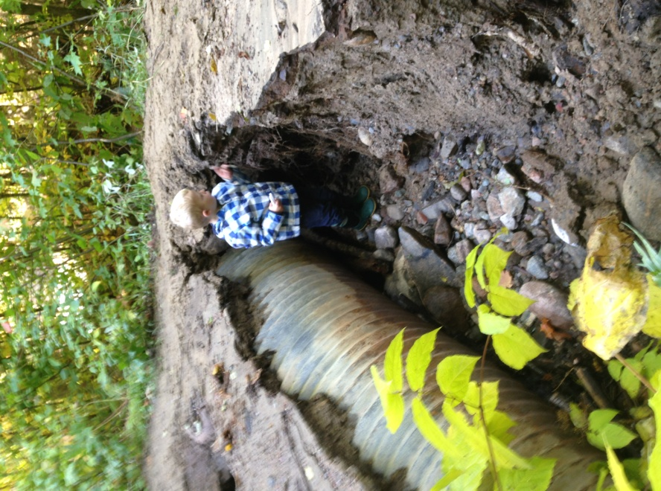This summer brought us many wet days and as a result, Mother Nature added yet another project to our list. Rainfall washed out a good portion of the “access road” on the blue trail. As you can see from the photos the water left some damage. We are hoping to head back out to this area to fix it up and ensure the trails are set and ready for the upcoming season. We are looking forward to another great season. Our trail maintenance projects will not go unnoticed and we all look forward to getting back out there.

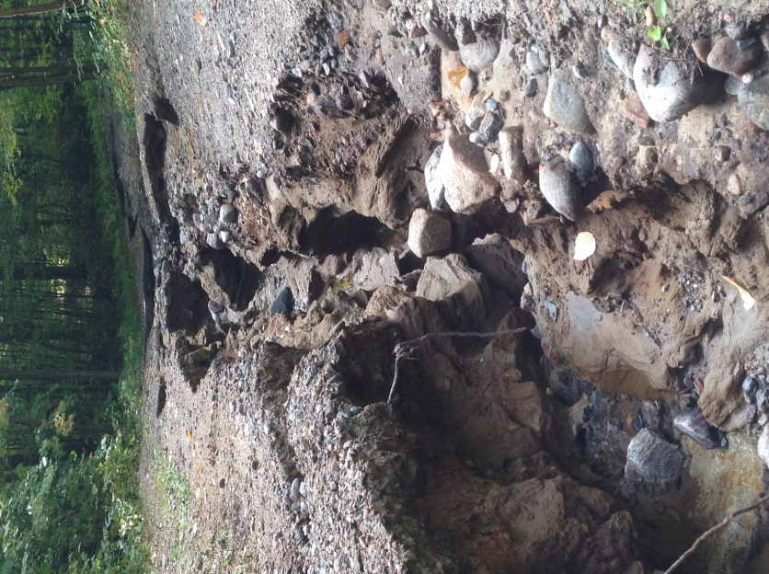

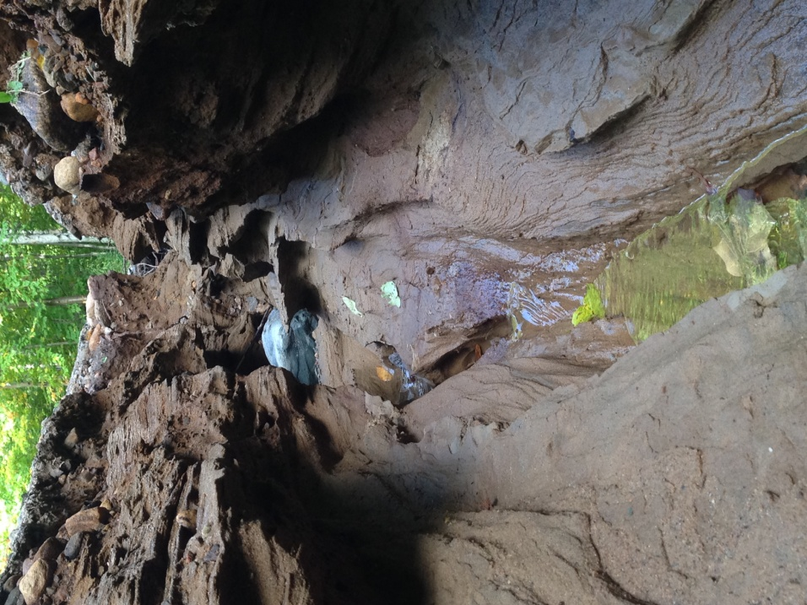



Board of Directors

John Bowes

**President**

Tom Cook

**VP, Building and Property**

Kelly O’Grady

**Trails**

Gary Jodouin

**Treasurer**

David Weiskopf

**Membership**

Julie Bass

**Newsletter, Secretary, Socials**

Mike Ward

**Club Races**

Erin Fettes

**School Liaison**

Amy Bartlett-Gibson

**Ski Programs**

Contact any of the board of directors at: [info@northbaynordic.ca](mailto:info@northbaynordic.ca)

C:\Documents and Settings\Julie Risling\Local Settings\Temporary Internet Files\Content.IE5\E3ZEDV6N\MC900021628[1].WMF

2014 Annual Cross Country Ski Exchange

Saturday, November 22, 9:00 – 12:00 a.m.

The Club’s Junior Race Team is once again holding the annual ski exchange on the 22nd of November. This is a great time to sell old skis and/or pick up new ones for skiers of all levels.

**New This Year**: We have arranged with Bay Builders (across from Stockfish Ford) that equipment can be dropped off at their location anytime between 10 a.m. to 5 p.m. weekdays from October 1st to November 20th. Otherwise, bring your cross-country ski equipment to the clubhouse Friday, November 21st between 4 and 7:30 p.m.

Doors open at 9:00 a.m. sharp on the 22nd.

Cycleworks, Lefebvres, and One Way will be on hand with both new and used ski equipment, packages, and clothing.

20% of the proceeds from the sale of your equipment will go to support the Junior Racing Team. You receive the balance of the selling price.

Bring your skis to the club during the exchange and the race team will hot wax, scrape and brush them to get them fast and ready for the season at a nominal fee of $10.

You will be able to purchase your 2014-2015 membership too at early bird pricing.

C:\Documents and Settings\Julie Risling\Local Settings\Temporary Internet Files\Content.IE5\E3ZEDV6N\MC900021628[1].WMF